**Assignment No:-6**

Name:-Suryawanshi Sangramsingh Sambhaji

Batch:- Delta - DCA ( Java ) 2024 Date:-7/5/2024

**1. Write a Java program to print the reverse of all numbers between a ranges of 51 to 71.**

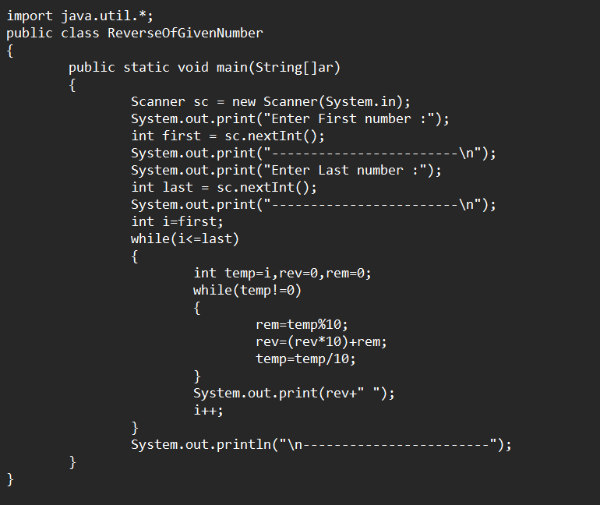

**Output:**

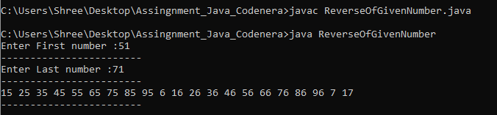

**2. Write a Java program to generate the prime numbers between 50 and 80.**

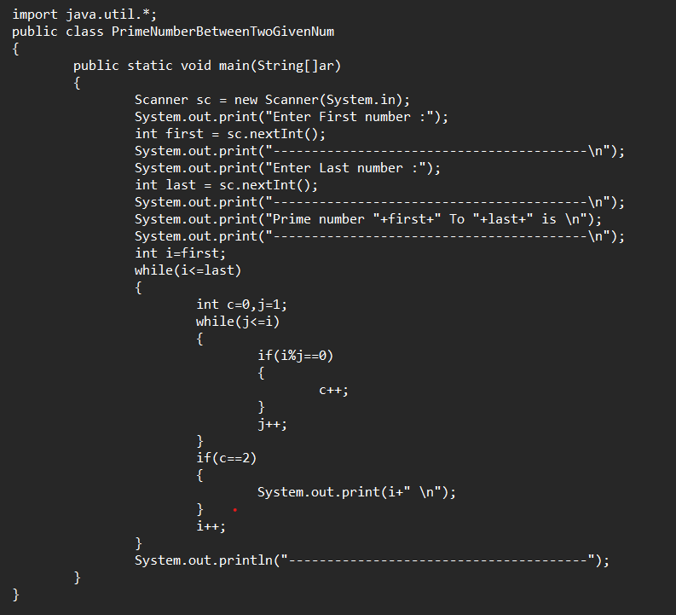

**Output:**

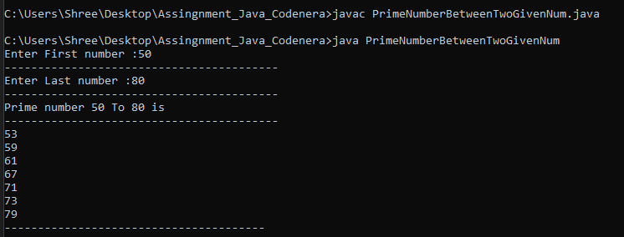

**3.** **Write a Java program to generate non-prime numbers between 100 and 150.**

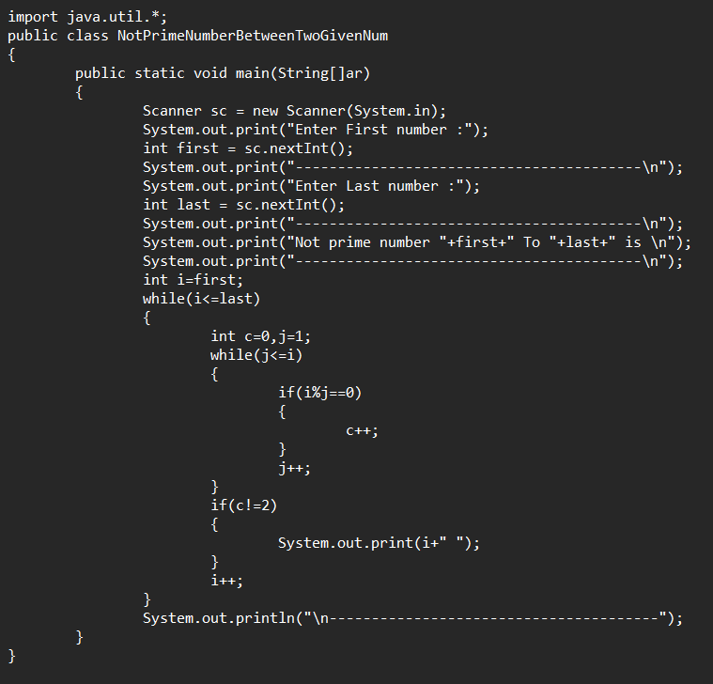

**Output:**

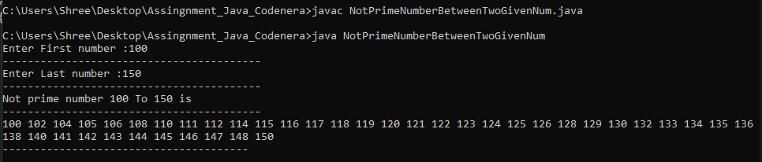

**4. Write a Java program to generate numbers between 100 and 150 that are multiples of 7.**

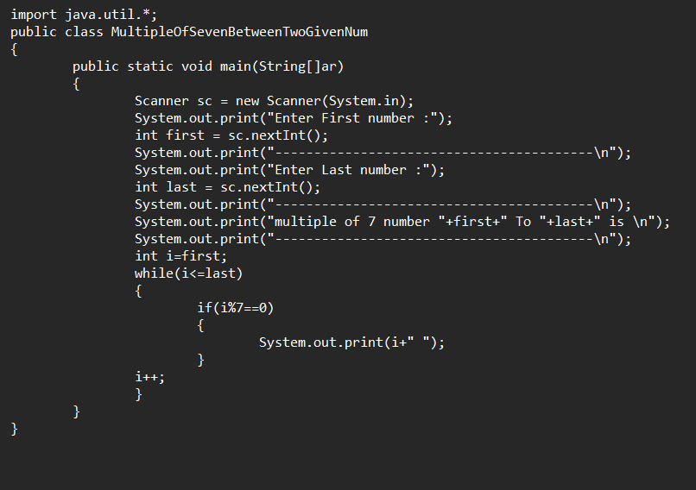 **Output:**

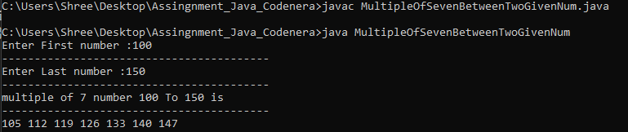

**5. Write a Java program to find all pairs of integers within a given range whose sum is equal to a specified number.**

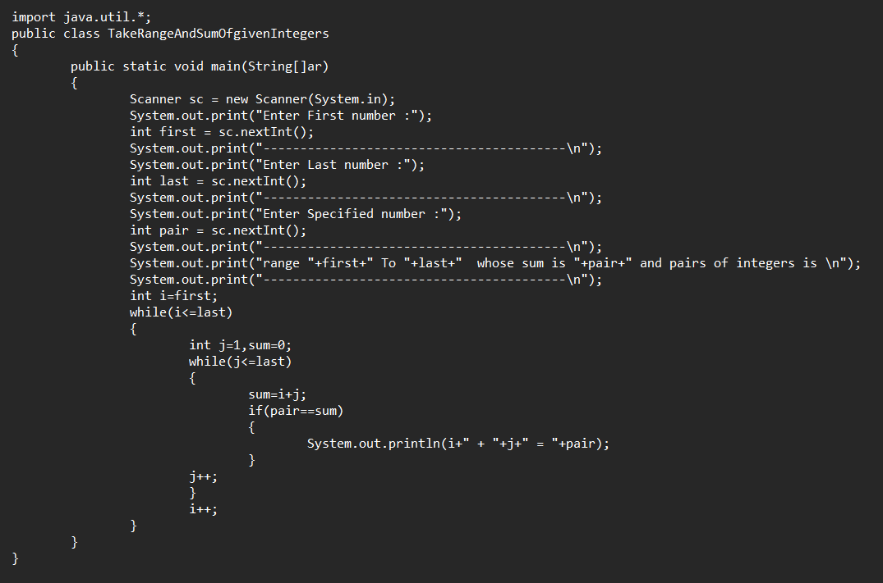 **Output:**

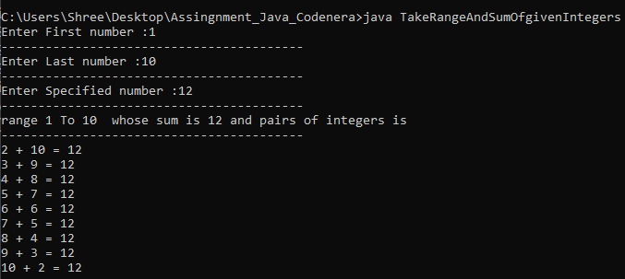

**6.** **Write a Java program to calculate the product of pairs of numbers which is equal to a target from a range of integers.**

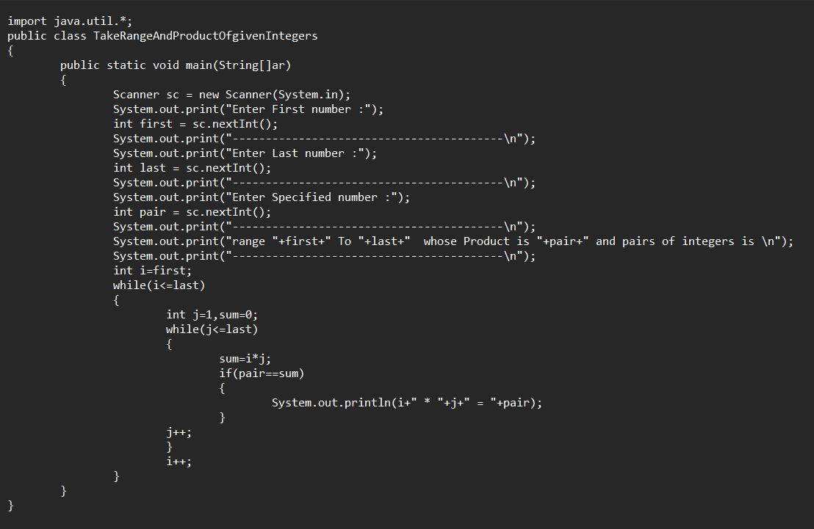

**Output:**

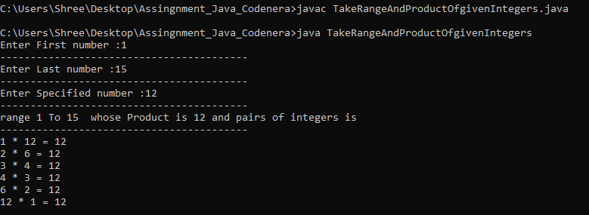

**7. Write a Java program to find the palindrome numbers between 10 to 100.**

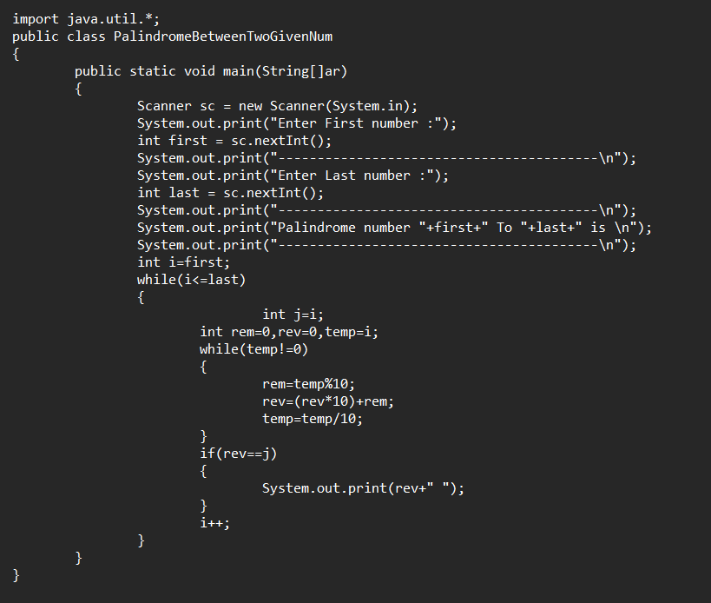

**Output:**

